IM1 Chapter 1 Answers
Lesson 1.1.1 #1-4,6-10  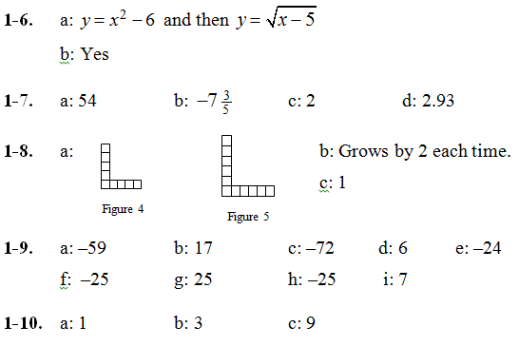 | Lesson 1.1.2 (Day 1) #11,15-18  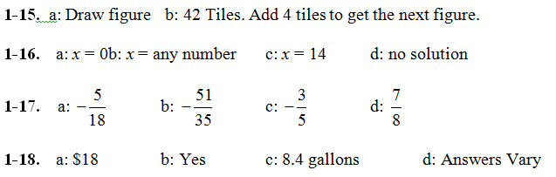 | Lesson 1.1.2 (Day 2) #12-14,19-24  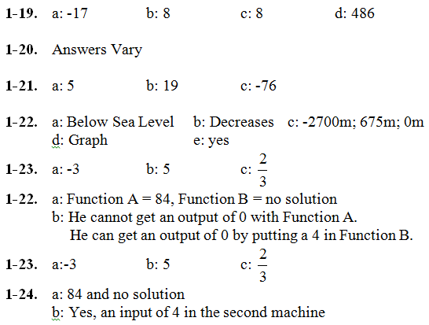
Lesson 1.1.3 #25-32  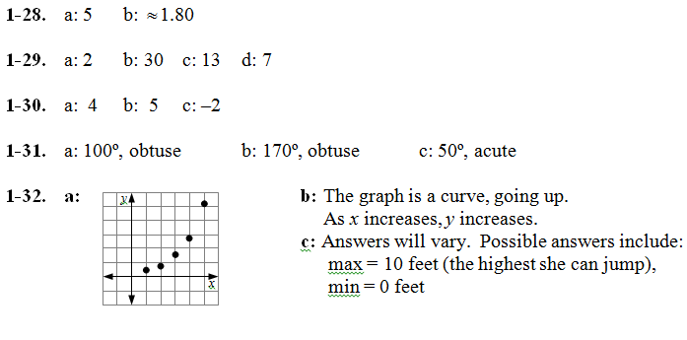 | Lesson 1.2.1 #33-41,42*  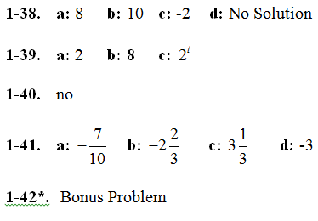 | Lesson 1.2.2 #43-51  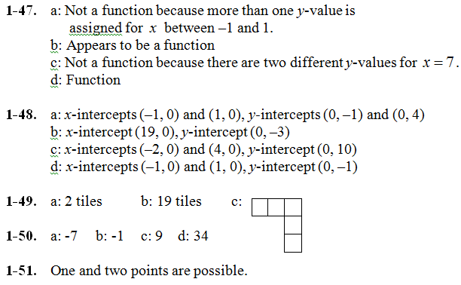
Lesson 1.2.3 #52-63  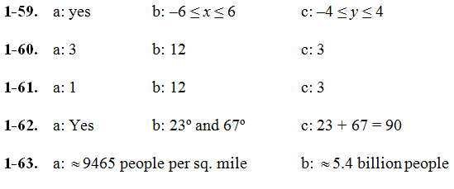 | Lesson 1.3.1 #64-72  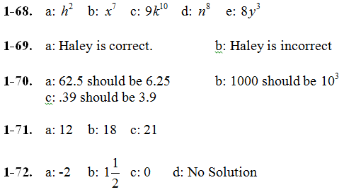 | Lesson 1.3.2 #73-85  